Auto keyword: I can’t believe it’s not Python! tm



Nullptr. It’s like NULL, but a type rather than a 0.

You can not set an int to nullptr like you could NULL. Nullptr is its own type and not 0.

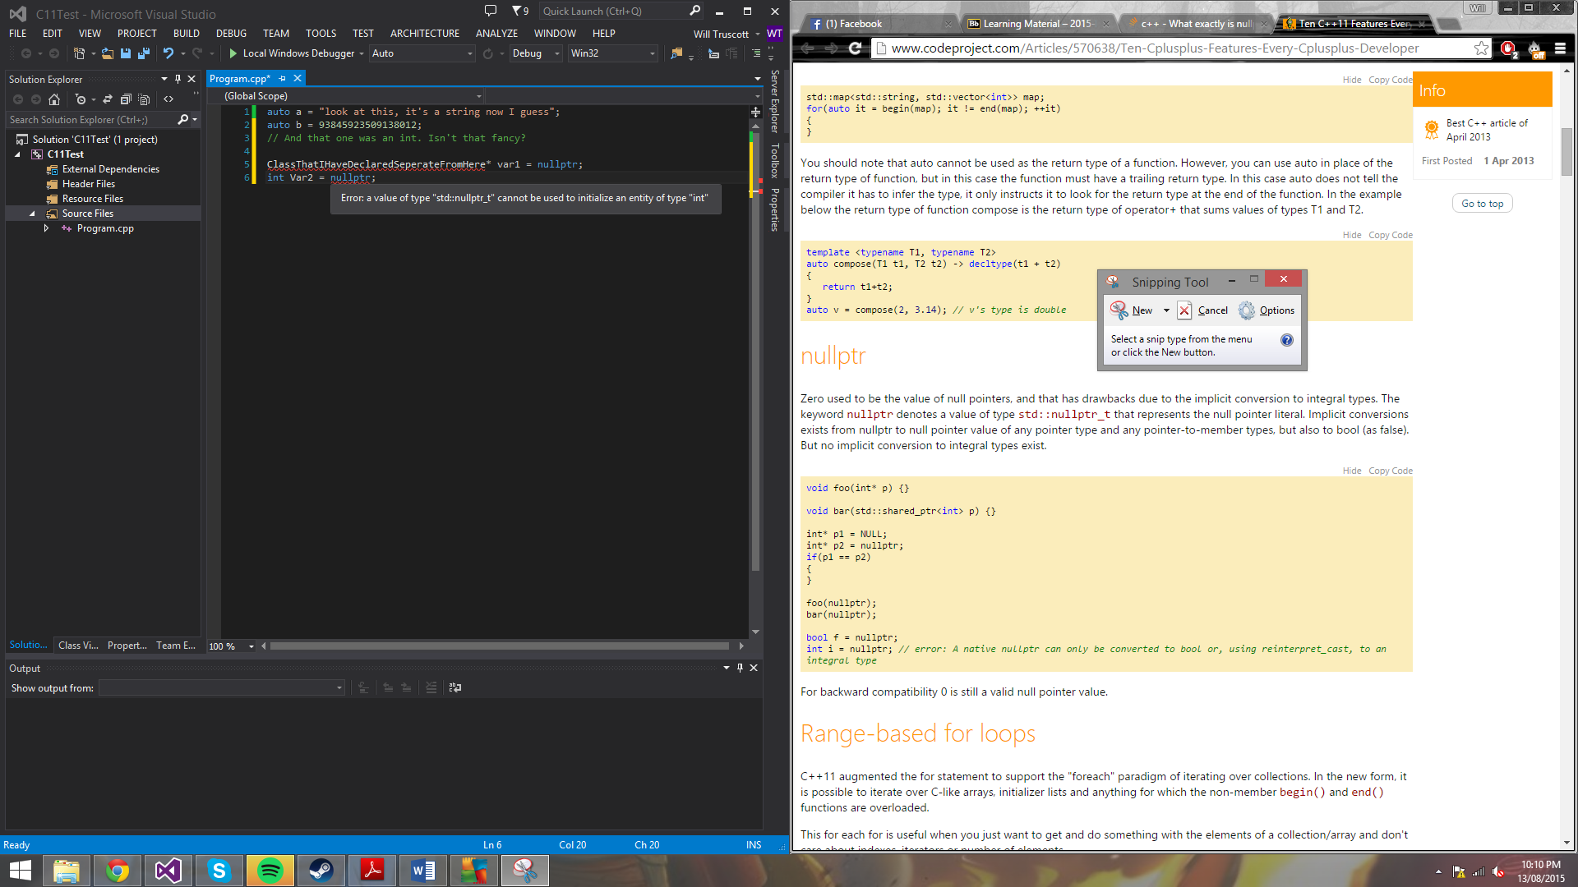

Range-based for loop: for when a regular for loop is deemed unreadable and barbaric.

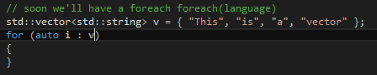

Override and final keywords: For those overridden with the desire for properly defined code.